Tinder Mini

Version 1.1

Revision History

|  |  |  |  |
| --- | --- | --- | --- |
| **Date** | **Version** | **Description** | **Author** |
| 29/11/2022 | 1.0 | A basic description version of the Software  Architecture Document. | Ho Si Duc  Nguyen Van Hieu |
| 14/12/2022 | 1.1 | Fix bugs, add section 5.6 | Ho Si Duc  Nguyen Van Hieu  Nguyen Hai Dang |
|  |  |  |  |
|  |  |  |  |

Table of Contents

1. Introduction 4

2. Architectural Goals and Constraints 4

3. Use-Case Model 5

4. Logical View 6

4.1 Component: View 7

4.2 Component: Controller 7

4.3 Component: Model 7

4.4 Component: Contact 7

4.5 Component: Authentication 7

4.6 Component: Map 7

4.7 Component: Entertainment 7

5. Deployment 8

6. Implementation View 8

# Introduction

The Software Architecture Documentation provides an overview of the entire Software Architecture Documentation of the software. It also includes the constraints and goals of the system's non-functional requirements. In addition, The Software Architecture Documentation provides a presentation of the architecture with its components and relationships among them.

# Architectural Goals and Constraints

* Performance and scalability: when using an application, the user will notice the delay, but the flow of thought will not be interrupted. The system must be scalable enough to support 10000 visits at the same time while maintaining optimal performance.
* Portability and compatibility: Application can launch on phones, tablets Android 9 Pie or above. 2GB of RAM and 4GB of RAM recommended, Hard disk space requires 2-5GB of free space.
* Reliability, maintainability, availability: The system must perform without failure in 85 percent of cases of use during a month. The mean time to restore the system (MTTRS) following a system failure must not be greater than 1day. MTTTRS includes all corrective maintenance time and delay time.
* Security: The system must secure the user information and does not allow permission to take pictures or videos.
* Localization: Responsive design suitable for young Vietnamese.
* Usability: Users can successfully use the system after 2 hours of use, users must successfully pair after at most 30 interactions with other people.

# Use-Case Model

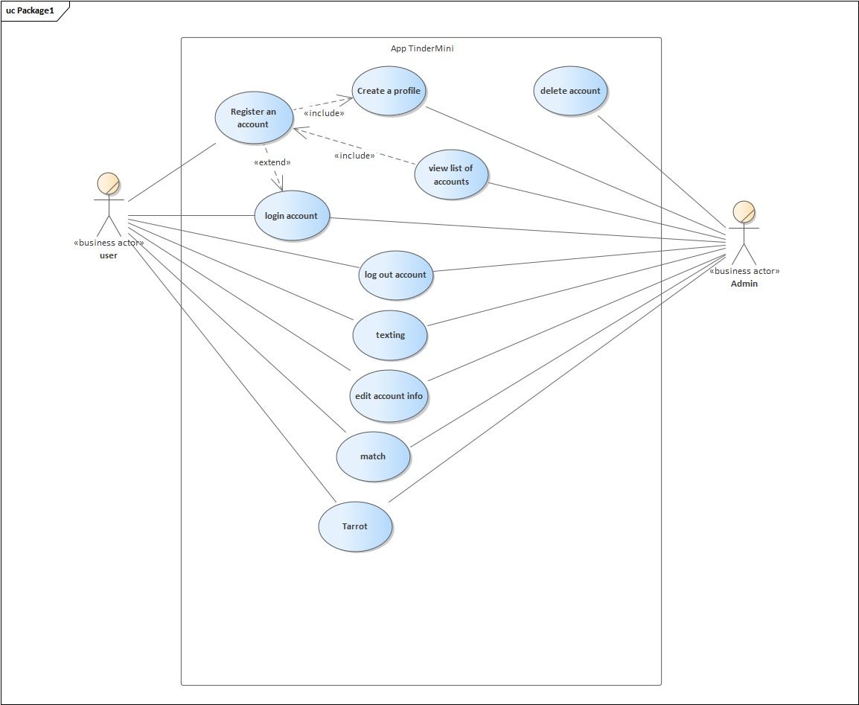

# Logical View

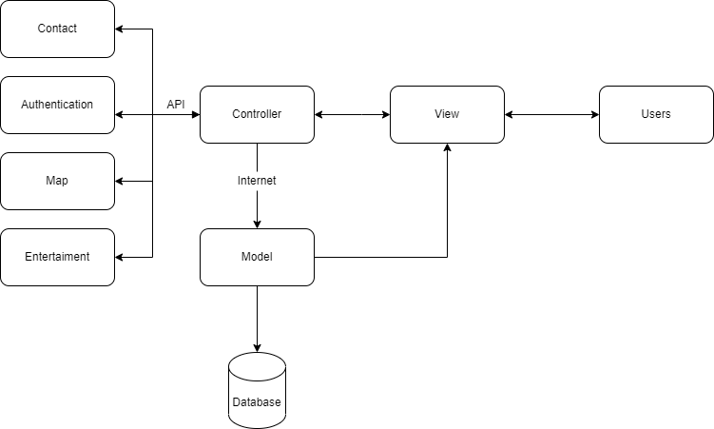

Figure 1. Software Architecture.

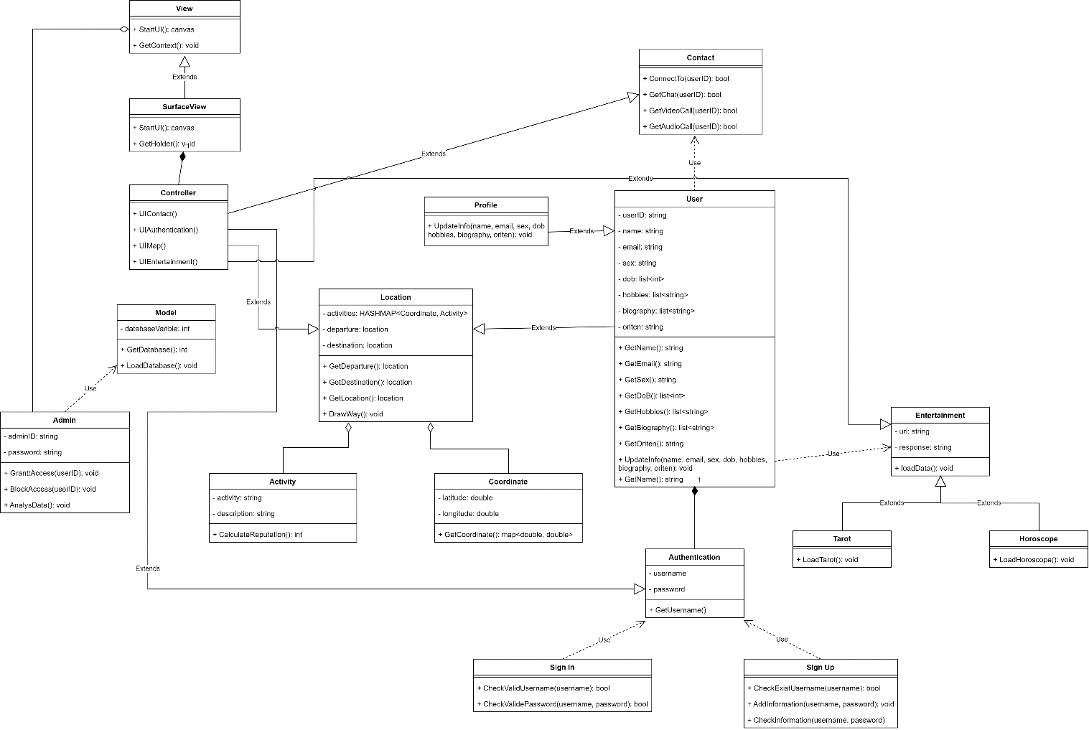

Figure 2. Class Diagram.

## Component: View

This component has the function of displaying the user interface, includes what people see, feel, and interact with when using the Application.

This component represents the data returned from the component Model and displayed to the user and provides an interface to help the user interact and make his request.

UI Application is designed based on UI Figma and defined on xml files.

## Component: Controller

This component has the function of accepting, processing, converting and transmitting the request.

This component connects to other components through API to help process requests from users, defined mainly in java language in files using the SKD Library. In addition, this component also deals with logic and rules responsible for data exchange, operations and workflows.

## Component: Model

This component has the main function of storing data and returning data when requested from the Controller.

This component keeps a profile of the user, the library, and records their activities on the Application and their interactions with other users. All the above functions are only performed when the Application connects to the internet to use a service that Firebase provides, Realtime Database.

Uses a service called Realtime Database that allows users to store and synchronize data in real time. This service is stored directly on iCloud.

## Component: Contact

This component helps connect users, interact between users.

The most important goal of the application is to connect users with each other, so this component provides all the functions for users to make their connection and interaction. The functions of this component are functions: like, dislike, chatting, call and the most important function is match.

## Component: Authentication

This component provides user authentication functions to be able to use the application and personalize for later use.

To be able to use the main functions of the Application and personalize and optimize the user experience, before using the Application, the user should use an account. This component contains all the functions for managing user accounts such as: login, register, logout.

To manage user accounts this component uses a service provided by firebase which is Firebase Authentication. The Firebase Authentication service provides your application with several authentication methods via email, password, phone number, Google account, Facebook account.

## Component: Map

This component helps locate the user to assist the Application when running functions like Match.

Determining the user's location is necessary for some of the Application's functionality, since the internet component uses the Google Map’s API to locate the user.

The Application uses Google Map’s API mainly to determine the location between two people to implement the Match algorithm that best suits the user, along with it is used to display the map, find the way or the location. suitable for dating.

## Component: Entertainment

This component offers a method of entertainment for users: reading Tarot cards, reading zodiac signs, etc.

In addition to the main function of the application, which is to connect people, the application must provide entertainment features such as reading the fortune-telling of the day to know a happy prediction of a lucky or difficult day or watching the zodiac for people, use from the user's date of birth data to return the zodiac sign and can suggest functions according to the zodiac, for example.

# Deployment

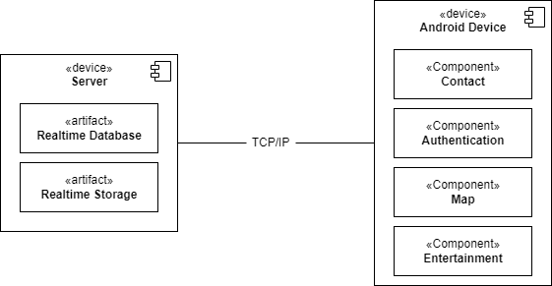

# Implementation View

